Jan./Feb. 2023 | Carmichael Chronicles  Brighton City Museum |  |  |  | Volume: 1  Issue #1
Our New Exhibit  The latest updates  We are open! Come see the new core exhibit, "Splendid Valley and Brighton: Story of a Place." We also have exhibits throughout Historic City Hall. Come and visit us Monday, Tuesday, Thursday, and Friday (11 a.m. - 3 p.m.) Our museum is free to visit, but we always accept donations.  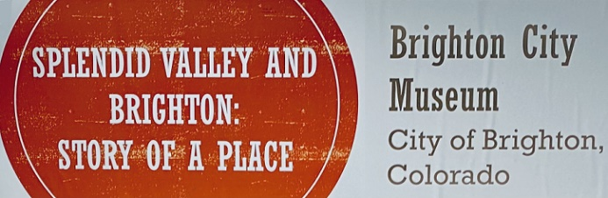  Looking for answers?  Trying to find that old address where you used to live? How about Grandpa's crazy cousin's criminal history? We can help you find answers to those long burning questions about local and family history! Simply go to this page and click the link under "research" and fill out the research request form:  https://www.brightonco.gov/FormCenter/Community-Development-4/Brighton-City-Museum-Research-Request-Fo-130.  Check Your Attic!  The Brighton City Museum is presently taking in specific items of Brighton’s past. If you have an item that you believe is one of a kind to telling Brighton’s history, or other questions about the donation process and what items we are currently seeking, call Bill Armstrong, Museum Specialist, at: 303-655-2288. |  |  | 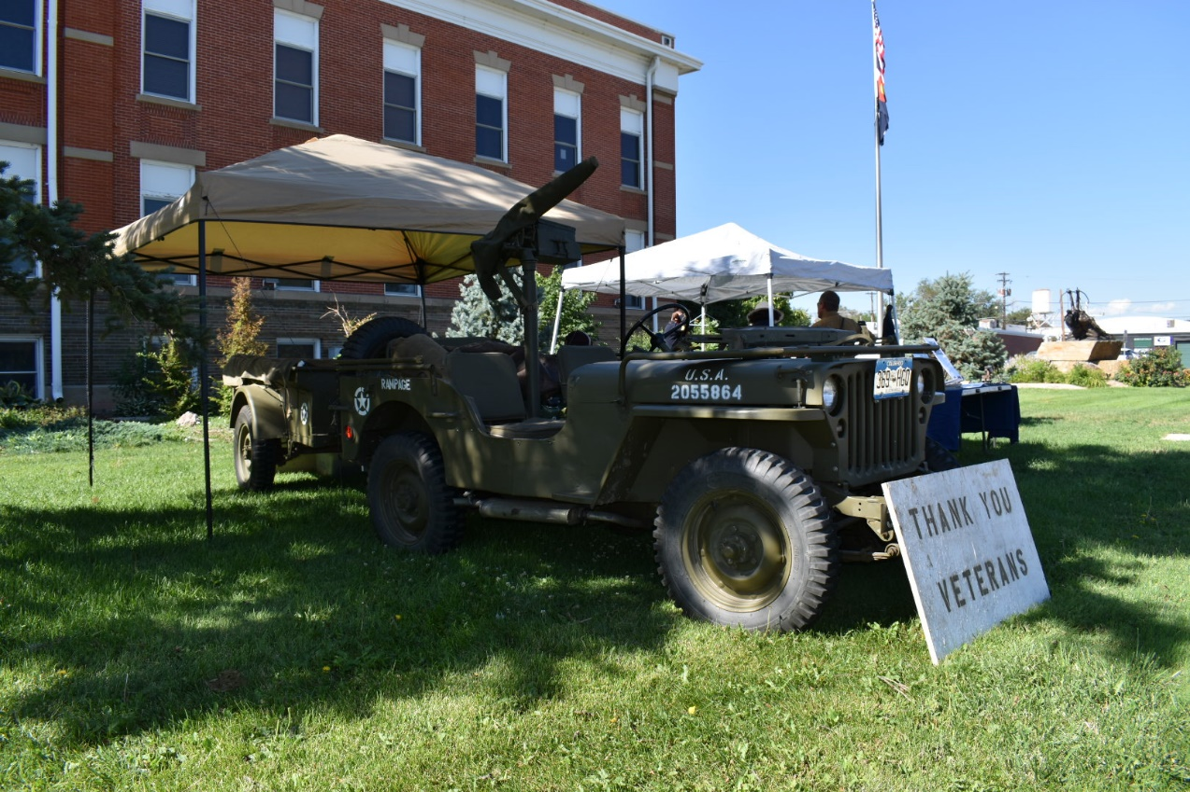
 |  |  | "Military History Event." Photo By: Rich Knapfel
Available Resources at the Museum
- Brighton Blade newspapers 1903 – 2016
- City Directories 1923-1981
- Adams County Register newspapers - various dates
- Japanese American News 1941 - 1958
- The Nichi Bei newspapers - various 1940s
- Colorado Times newspapers - various 1940s
- The Rocky Nippon newspapers - various 1940s
- The Rocky Shimpo newspapers -various 1940s
- 1916 Willits Farm Map
- Other City aerials & other historic regional maps
We also have our collections on Past Perfect Online!
We are working on re-cataloguing items. Please be patient with us if you are unable to find an item that was under a previous catalogue number
 |  |  | Did You Know?  The City of Brighton was originally called Hughes Station. It was named for the first president of the Pacific Railroad, Bela Hughes. The name was changed to Brighton in 1879. The new name was officially accepted in 1881 when Daniel Carmichael plotted the first subdivision in town.  And…  The Frink family started one of the largest and most successful creameries in Brighton.  The Frink Cheese Factory would later become the Northern Colorado Dairy, located at 235 N. Main St. in Brighton. | Exhibits  Current Temporary Exhibitions:  “A Reserve of Public Service: The History of Brighton's Armory"  It has been nearly 100 years since Brighton's Armory has been standing. Come learn about why it was built, its multiple uses for our community, and its renaissance into a Performing Arts Center.  
The History Of Our Museum

The Brighton City Museum was established in 2016 by the Brighton Historic Preservation Commission when newspapers and artifacts were found during the renovation of Bromley Koizuma-Hishinuma Farm. The Commission decided it was worth becoming a State Repository to keep those items in the city for the community to learn more about their history. Thus a museum was born. Over the years, we collected, donated and saved items pertaining to our city's history, adding to nearly over 10,000 items. Come visit us to see the latest exhibits and learn more about the history of Brighton!

2022 Christmas Open House

On December 10^{th,} we held our annual “Old Fashioned Christmas Open House” event. The open house was held prior to the Christmas parade and was a huge success.

Our guests were served hot chocolate / hot apple cider and cookies. In addition to the goodies, two craft stations were in place; so that everyone could create popcorn/cranberry strings and paper chain tree decorations.

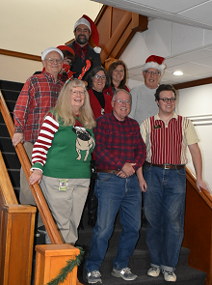

Curator’s Notes

With all this success, it is time to put our eyes on 2023. What will the future bring? In the planning phases now are two new exhibits focusing on our more unusual items in our collection, and a focused exhibit on the efforts to preserve some of our oldest homes.
Additionally, the staff are pursuing grants to take the unique history of Brighton to local schools, underwrite events, and bring more visitors than ever to the museum. Since the designation of the Black Cemetery, the museum has assumed ownership of the resource, which will become the focus of pioneer and graveyard history within the community as part of our expanded programing. We look towards spring to add lectures and “first Friday” evening open house events.
We invite you, our community members, to become involved. The Brighton City Museum still has plenty of room for volunteers. We always try to marry interest with drive and passion for the past. What better way to help your community than to help preserve its unique story for future generations? The staff believe that “many hands make for light work “especially while feeding your interest in history and educating others.
Welcome to a new bright year for Brighton City Museum! Please consider donating to the Museum your talent, time, or heirlooms to help us meet our mission of educating our community, visitors to the city, and youth about Brighton’s unique history.
With your assistance 2023 will surpass 2022!
New To Our Collection!

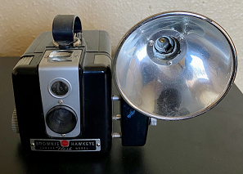
Kodak Brownie Hawkeye Camera - Photo by Rich Knapfel

Recently, we added this Kodak Brownie Hawkeye Model 620 camera to our collection. Kodak produced these cameras between 1950 and 1961. The camera used the old 620 mm film, which is no longer available. If you are a camera enthusiast, come on down and check it out!

2023 Fee Schedule

 Historic Preservation Sales
Brighton-Fort Lupton: At the Dawn of the Millennium 2000 - $20/each
Brighton Reflections: Brighton City Hall 100 Year Commemoration 1906-2006 - $5/each
Railroad Reaches Hughes Station, June 9, 1870 - $5/each
Centennial Paintings Cards - $5/each

 Research and Retrieval Fees
Up to 1 hour - Free
Research time exceeding 1 hour - $20/hour after the first hour

 Copies
Color map (11"x17") - $5/each
Color Map (18"x 24") - $12/each
Color Map (24" x 36") or (24" x 30") - $15/each
Color Map (36" x 45") or larger - $20/each
Black & White Copies:
Letter or legal size - $0.25/page
Color Copies:
Letter or legal size - $1/page
Photographs: $3/photograph

 Information

Call: Bill Armstrong at 303-655-2288

Individual research is permitted by appointment only.

