April - June 2024

Brighton Nisei Women's Club

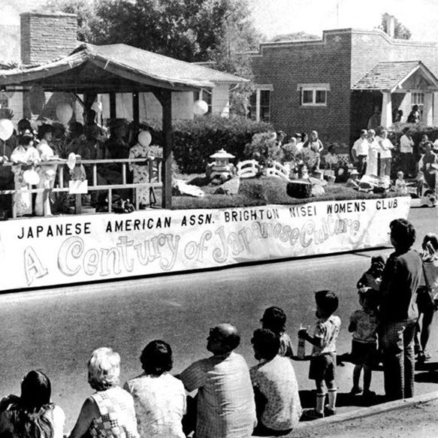
Brighton Nisei Women's Club float during a parade near downtown Brighton. (1976 Bi-Centennial Parade)

The Brighton Nisei Women's Club is of instrumental importance as it speaks to our city’s heritage and important community groups.

In the book "Brighton and the Surrounding Area 1887-1987", Emi Chikuma wrote an entry on the group that noted, "The Brighton Nisei Women's Club was organized in 1948 for the Nisei women of Japanese Ancestry, for the aim and purpose of promoting the welfare of the Japanese American society…The club has a membership of 60 ladies who live in Brighton, Fort Lupton, and Henderson area. The name 'Nisei' means the 2nd generation born of the 1st generation (Issei) to come to the United States." The group even printed its first (but not last!) cookbook in 1960.

The photograph was taken near the corner of 4th and Bridge looking roughly north by northeast. The parade float is moving along Bridge. You can see the historic brick building in the upper right-hand corner of the photo. Those structures were built at the corner of Bridge and 5th in the mid-1930s.

Get Ready for Baseball!
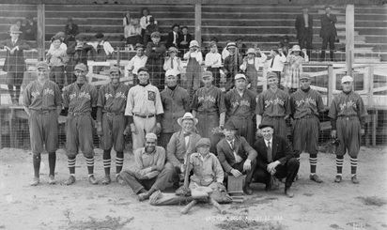
With the 2024 baseball season upon us, we thought this would be a good time to share one of our favorite photos.

The picture shown here, is of the Brighton Boosters baseball team as it posed for a photo on August 22, 1920. The team was at the Adams County Fairgrounds, which was once where City Hall is today, at S.4th Avenue. Brighton’s own Duke White can be seen sitting at the front left of the photograph.

The Carlson Farm

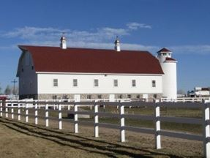
This photograph is of the farm located at 14095 Brighton Road, also known as the Carlson Farm. Its history was studied during our 2016 grant project named the "64 Farmsteads Survey." The farm is located within Historic Splendid Valley and is featured in our Historic Splendid Valley Digital Tour, which can be found, on the internet, at: https://buff.ly/2BgtsOR

Here's a bit of history from the Digital Tour! Brighton was once the center of the dairy industry in the state. The Carlson Family contributed to the growth of Brighton. The Carlson Dairy contributed to the Brighton Creamery, the Sinton Dairy Factory, and later the Northern Dairy Factory. In fact, this farm has contributed to many of the economic drivers in Brighton.

Coxey’s Colorado Army

While discussing the economic history of the United States, little is spoken about the “Panic of 1893.” The primary causes for this economic upheaval can be traced to the failure of two major employers, the Philadelphia & Reading Railroad, and the National Cordage Company. As a result, between 17- 19 percent of the workforce became unemployed.
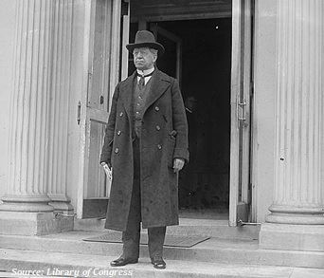
The consequences for the unemployed did not go unnoticed. An Ohio entrepreneur, by the name of Jacob Coxey, took note of their situation and devised a plan to alleviate the hardships sustained by the workers.
Coxey’s plan was to petition congress for the allocation of funds for the building and maintenance of roads, which would employ thousands of workers. His plan included a march on Washington to sell this idea and put people back to work. Those participating in this march were known as “Coxey’s Army.”
Jacob Coxey led a group of approximately five hundred men from the Midwest to Washington. Meanwhile, as word of the movement spread, many other groups of unemployed workers came from points further west.
In May of 1894, the Brighton Blade printed an article describing the Colorado members of Coxey’s Army travelling from Denver, by large flat-bottomed boats. These boats were described as propelled by men with “crude oars” made from ”2 x10 pieces of lumber”, as they made their way along the Platte River. Unfortunately, their journey was met with adversity when they were caught in the “swirls” of the river and “upset.” As a result, six to eight of the crew members were believed to have drowned and got no further than Brighton.
The Colorado delegation never made it to Washington. The remaining group, of about one hundred and fifty, continued their travel on foot, and got as far as the Missouri River, where their journey ended.
As for Jacob Coxey, he and his followers were arrested on the grounds of the capitol and charged with trespassing. The failed march was the first of two involving “General Coxey.” The second occurred in 1914 which resulted in a similar outcome.
 Shining Star of The Quarter


Gandhi once said, “The best way to find yourself is to lose yourself in the service of others.” During the summer of 2023, Gordon Sitterly became a volunteer at the Brighton City Museum. As a longtime student of history, Gordon has made his mark as a valuable asset to our museum.
Since joining the museum, Gordon has assisted the staff with researching and writing about the history of the city’s railroad and stagecoach connections. He is currently working on a project to honor Brighton’s military veterans and their service.
Gordon takes great pride in the work that he has done and has said “his greatest reward has been connecting with others who share a passion for our history and heritage.”
Congratulations Gordon! Your dedication and outstanding contributions have earned you the title of “Shining Star of the Quarter.”

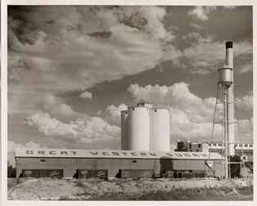

Did You Know?

On June 8, 1916, the Farms and Merchants Association of Adams County announced that negotiations had been conducted with the Great Western Sugar Company to build a factory in Brighton. Construction began in September of the same year on the north edge of Brighton.
When the factory began operation in 1917, it had a capacity of 600 tons of beets per day.

Looking for answers?

Trying to find that old address where you used to live? How about Grandpa's crazy cousin's criminal history? We can help you find answers to those long burning questions about local and family history! Simply go to this page and click the link under "research" and fill out the research request form:
https://www.brightonco.gov/FormCenter/Community-Development-4/Brighton-City-Museum-Research-Request-Fo-130.
We also have our collections on Past Perfect Online!
We are working on re-cataloguing items. Please be patient with us if you are unable to find an item that was under a previous catalogue number.

