Carmichael Chronicles
Brighton City Museum
Collaborations & Partnerships  Last year, the museum kicked off a monthly speaker series about topics related to the history of Brighton and the west. These “First Friday” discussions were hosted by the Brighton Chamber of Commerce and their magnificent staff. By doing this, we established strong ties with the Brighton Chamber, and have garnered tremendous support from their employees.  As part of the informative discussions, we were also able to incorporate the talents of the Brighton High School – Family Community Career Leaders of America (FCCLA) team. Their culinary expertise contributed to the presentations about the foods of the west and traditional Christmas feasts.  The formation of these partnerships, and the services that they provided, attributed to the overall success of the First Friday Speaker Series.  This year, we hope to build on these partnerships and collaborative efforts, to bring you more insightful talks about our community and the old west. |  |  | 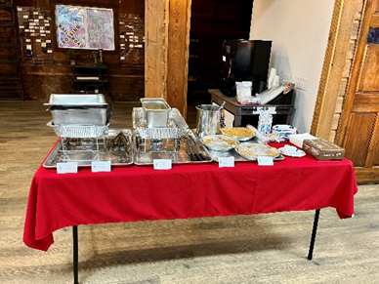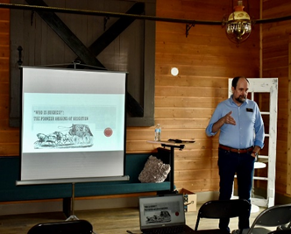

Cracker Jacks at the Museum
One of our newest exhibits, which is located on the second floor of the museum, features uniforms from the WWII era. One of the most interesting uniforms is the U.S. Navy jumper.
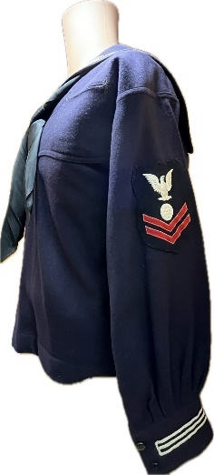
This “jumper” is part of the service dress blue uniform, which is still worn by sailors today. The uniform is often referred to as the “cracker jack” uniform because it is featured on a box of Cracker Jacks and worn by Sailor Jack. The cracker jack uniform is typically the “go to uniform” when a sailor is unaware of the clothing to wear for a specific occasion.
The jumper is just part of a two-piece set, with the bell-bottomed trousers completing the bottom half of this traditional uniform. The Navy jumper is adorned with piping (white stripes) around the cuffs and on the collar flap. The rating badge and service stripes are worn on the left sleeve of the uniform for those E-2 through E-6. In addition to the adornments on the sleeve, ribbons or medals are also required as part of this uniform.
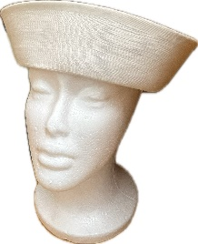
The enlisted hat or the “Dixie Cup” was initially made from canvas. The hat, according to the United States Navy Uniform Regulations, should be worn “1-1/2 inches above the eyebrows and not crushed bent or rolled.” Historically, in defiance of the uniform regulations, sailors would bend or roll them for easy storage when not in use.

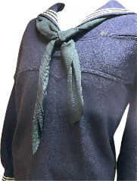
The “neckerchief” as it is called, was designed as a sweatband and colored black to hide the dirt. The neckerchief, worn around the neck and under the jumper collar, is made from a 36-inch square piece of black silk. To properly tie the neckerchief, the silk square is folded, into a triangular shape and then rolled tightly. Once rolled, it is tied in a square knot at the point where the jumper collar begins.

Since the middle of the 19th century, this iconic uniform has been proudly worn by the naval enlisted personnel and proudly displayed in many ports around the globe. First Lady Mamie Eisenhower once remarked: “Ike says the sailors use language they wouldn’t want their mothers to hear, wear their uniforms so the spots won’t show, and still manage to be the best-dressed branch in the service.”

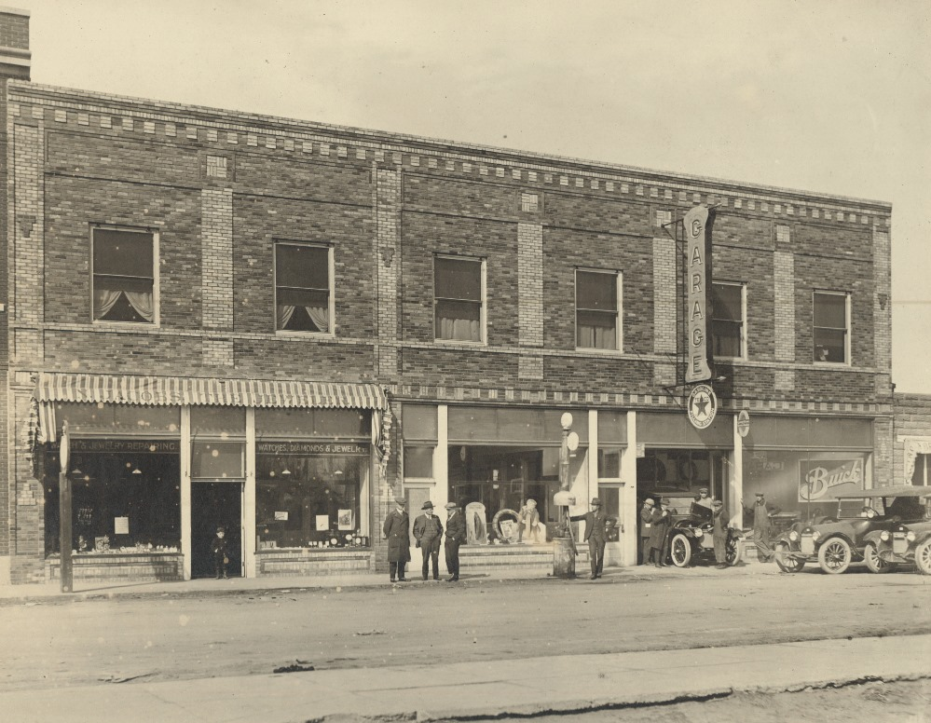
Jacob The Jeweler

This is a photograph of 117 N Main, in our Downtown Historic District. The building's historic name is the Homann Building. A business called Jacob the Jeweler had a retail storefront in the early 1900s that you can see on the left-hand side of the photo. Today, if you walk by 117 N Main, the jewelry store would have been located in the section of the wall that has been bricked-up next door to Something Brewery.
In 1981, an historian completed a cultural resource survey of this building and noted the following: "This structure was named for Herb Homann, one of Brighton's downtown businessmen. During the late 1920s, when Ray Benedict's furniture business occupied the building, it became known as the Benedict Furniture Company. Since the time of its construction the building has provided space for a variety of commercial purposes, including a car dealer, jewelry store, and candy shop."

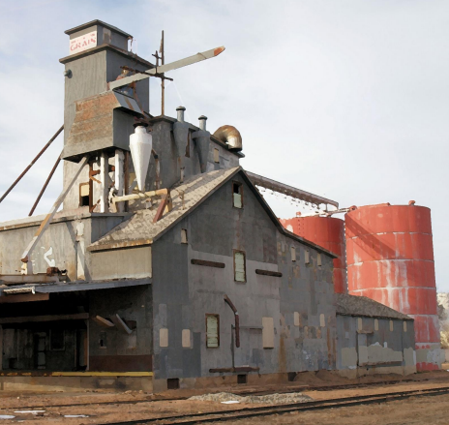
Brighton Grain Elevator

The Brighton Grain Elevator building typified the agricultural heritage that helped shape our city into the one we know today. When the Brighton Farmer’s Cooperative Elevator Company was incorporated in April of 1919, it was housed at the Grain Elevator and served farmers in the area in various capacities for roughly the next 80 years.

From form 5AM.3220, "In 1923, the Brighton Farmers Co-op sold grain, flour, and feed, the Champion line of farm implements, and the Max Hewitt line of tires and tubes. The city directories through 1931 continue to list the business as the Brighton Farmers Elevator Company. By 1933 and 1935, it was called the Farmer’s Cooperative Elevator Company." Frank Ottesen purchased the building in 1938 and set out to modernize its operations and build additions. By 1948, the elevator's capacity was roughly 40,000 bushels.

Shining Star of the Quarter

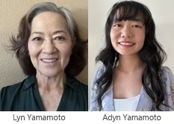
American author Elizabeth Andrew once said: “Volunteers do not necessarily have the time; they just have the heart.” At the Brighton City Museum, we also believe that a loving heart is what guides our volunteers to give back to their community.
This quarter we would like to highlight the contributions of a great team of volunteers. Adyn and Lyn Yamamoto have been volunteering at our museum since June of 2023. Since that time, this dynamic team has made a lasting impact on document processing as well as the overall organization of our collection.
On their very first project, Adyn and Lyn scanned, identified, and created an index for all of the Brighton Japanese American Association (BJAA) photographs. This was no easy assignment, but after months of extensive work, they were able to turn stacks of photographs into a very usable source of information.

Lyn and Adyn are currently working on a prized donation from a local Brighton family. Once completed, this collection will tell the story of the service of two local veterans from 1917 and 1953.

Congratulations Adyn and Lyn! Your dedication and outstanding contributions have earned you the title of
“Shining Star of the Quarter.”

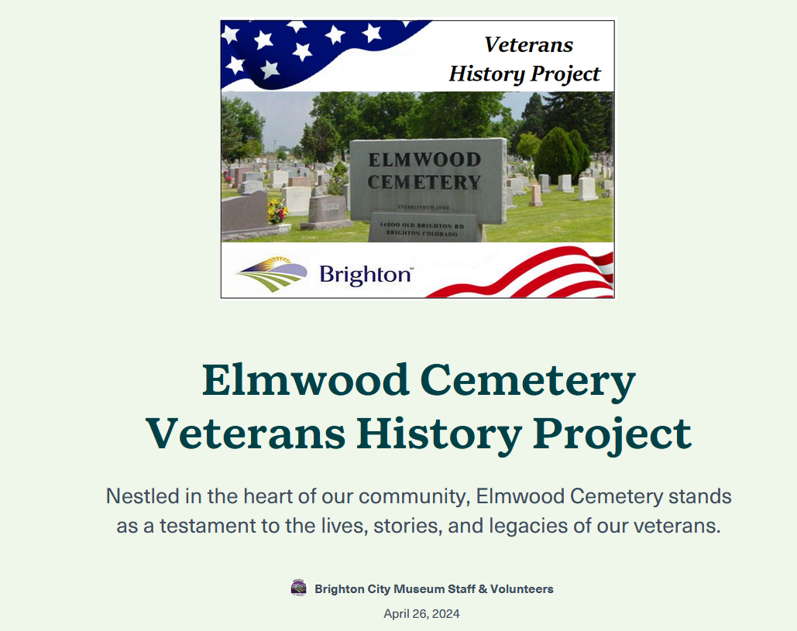
Something New!
As part of a partnership with Elmwood Cemetery, the Brighton City Museum has been involved with a new StoryMaps™ project. The purpose of this project is intended to tell the stories of former military personnel buried in Elmwood Cemetery.
This project will not only document the locations of those buried at the cemetery but will also provide some insight into their military service as well as their civilian life.
Once completed, this project will not only provide a resource for the locations of the burials but will also provide useful information for those interested in finding out more about our local military heroes.
To access the StoryMaps™ page navigate over to the web address or use the QER code.

https://arcg.is/Wvaf01

